**Analysing Amazon Sales SQL Queries**

**—-----------------------------SALES OVERVIEW—----------------------------------**

**(Regions)**

1. **List of distinct regions covered in Amazon’s sales data?**

ELECT DISTINCT(Region) FROM [dbo].[Amazon Sales data]

S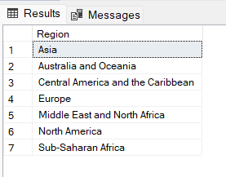

**(Total Sales Year)**

**2. Count of the total number of years covered in Amazon sales data?**

SELECT COUNT(DISTINCT(Order_Year)) AS Total_Sales_Years

FROM [dbo].[Amazon Sales data]

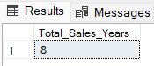

**(Total Countries)**

**3**.**Count of the total number of countries involved in Amazon sales?**

SELECT COUNT(DISTINCT(Country)) AS Total_Country FROM [dbo].[Amazon Sales data]

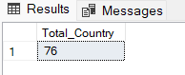

**(Total Items)**

**4.Count of the total number of distinct items available for sale on Amazon?**

SELECT COUNT(DISTINCT(Item_type)) AS Total_Items FROM [dbo].[Amazon Sales data]

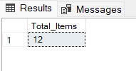

**(Sales Mode)**

**5. Different sales modes (sales channel) available?**

SELECT DISTINCT(Sales_Channel) AS Sales_Channel FROM [dbo].[Amazon Sales data]

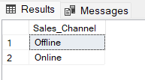

**—-------------------------------REVENUE AND PROFIT—--------------------------**

**(Total Revenue)**

**6. Sum of the total revenue generated across all sales?**

SELECT SUM(Total_Revenue) AS Total_Revenue FROM [dbo].[Amazon Sales data]

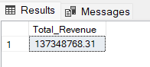

**(Revenue by Sales Mode)**

**7. Total Revenue generated by different sales modes?**

SELECT Sales_Channel,

SUM(Total_Revenue) AS Total_Revenue

FROM [dbo].[Amazon Sales data]

GROUP BY Sales_Channel

ORDER BY SUM(Total_Revenue) DESC

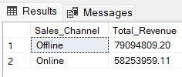

**8. The most sold item in each sales mode?**

WITH cte

AS (SELECT Sales_Channel,

Item_Type,

Sum(Units_Sold) AS Unit_Sold,

Rank()

OVER(

partition BY Sales_Channel

ORDER BY Sum(Units_Sold) DESC) Ranking

FROM [dbo].[amazon sales data]

GROUP BY Sales_Channel,

Item_Type)

SELECT Sales_Channel,

Item_Type,

Unit_Sold

FROM cte

WHERE ranking = 1

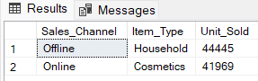

**(Least sold item by Sales Mode)**

**9. The least sold item in each sales mode?**

WITH cte

AS (SELECT Sales_Channel,

Item_Type,

Sum(Units_Sold) AS Unit_Sold,

Rank()

OVER(

partition BY Sales_Channel

ORDER BY Sum(Units_Sold) ASC) Ranking

FROM [dbo].[amazon sales data]

GROUP BY Sales_Channel,

Item_Type)

SELECT Sales_Channel,

Item_Type,

Unit_Sold

FROM cte

WHERE ranking = 1

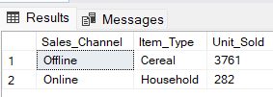

**( Total Items Sold )**

**10. Sum of the total number of sold items?**

SELECT SUM(Units_Sold) AS Total_Items_Sold FROM [dbo].[Amazon Sales data]

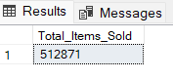

**(Total Cost of Sold Items)**

**11. Sum of the total cost of all sold items?**

SELECT SUM(Total_Cost) Total_cost_of_all_sold_items AS FROM [dbo].[Amazon Sales data]

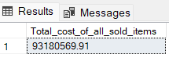

**---------------------PRICES INSIGHTS AND PROFIT MARGIN----------------**

**(Items and Selling Prices)**

**12. List of distinct items and their selling prices?**

SELECT DISTINCT(Item_Type) AS Item_Name,

Selling_Price AS Price

FROM [dbo].[Amazon Sales data]

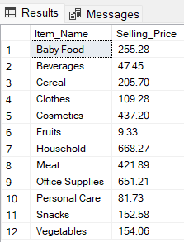

**(Items and Actual Prices)**

**13. List of distinct items and their actual prices?**

SELECT DISTINCT(Item_Type) AS Item_Name,

Unit_Cost AS Actual_Price

FROM [dbo].[Amazon Sales data]

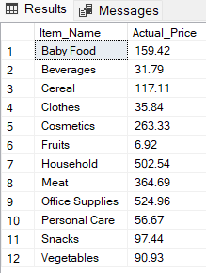

**( Gross Profit Margin )**

**14. List of items sorted from highest to lowest profitability?**

SELECT DISTINCT(Item_Type) AS Item_Name,

Unit_Price - Unit_Cost AS Profit

FROM [dbo].[Amazon Sales data]

ORDER BY Unit_Price - Unit_Cost DESC

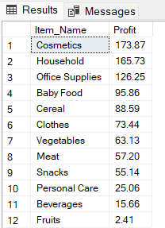

**(Profit Margin)**

**15. List of items sorted from highest to lowest of profit margine ?**

SELECT Item_Type,

FORMAT(SUM(Total_Profit) / SUM(Total_Revenue) * 100, '0.00') + '%' AS Profit_Margin

FROM [dbo].[Amazon Sales data]

GROUP BY Item_Type

ORDER BY Profit_Margin DESC

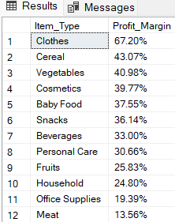

**(Most Expensive Item)**

**16. The most expensive item on Amazon?**

SELECT DISTINCT(Item_Type) ,

Unit_Price AS Price

FROM [dbo].[Amazon Sales data]

WHERE Unit_Price=(SELECT MAX(CONVERT(DECIMAL(10,2), Unit_Price))

FROM [dbo].[Amazon Sales data])

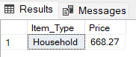

**(Cheapest Item)**

**17. The cheapest item on Amazon?**

SELECT DISTINCT(Item_Type) ,

Unit_Price AS Price

FROM [dbo].[Amazon Sales data]

WHERE Unit_Price=(SELECT MIN(CONVERT(DECIMAL(10,2), Unit_Price))

FROM [dbo].[Amazon Sales data])

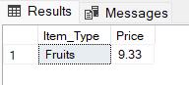

**—---------------------------DELIVERY PERFORMANCE—------------------------**

**(Average Delivery Days)**

**18. Average delivery days for each item type?**

WITH cte

AS (SELECT Item_Type,

DATEDIFF(day, Order_Date, Ship_Date) AS Day_Take

FROM [dbo].[Amazon Sales data])

SELECT Item_Type,

AVG(Day_Take) AS Average_delivery_day

FROM cte

GROUP BY Item_Type

ORDER BY AVG(Day_Take) ASC

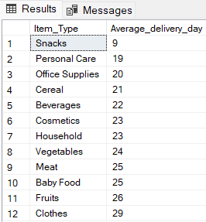

**-------------------------------------SALES ANALYTICS--------------------------------**

**(Top 3 Most Sold Items throughout Amazon Sales)**

**19. List of top 3 most sold items throughout Amazon sales?**

SELECT Top(3) Item_Type,

SUM(Units_Sold) AS Unit_Sold

FROM [dbo].[Amazon Sales data]

GROUP BY Item_Type

ORDER BY Sum(Units_Sold) DESC

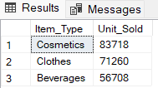

**(Top 3 Least Sold Items throughout Amazon Sales)**

**20. List of top 3 least sold items throughout Amazon sales?**

SELECT Top(3) Item_Type,

SUM(Units_Sold) AS Unit_Sold

FROM [dbo].[Amazon Sales data]

GROUP BY Item_Type

ORDER BY Sum(Units_Sold) ASC

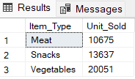

**(Most Sold Item by Each Country)**

**21. Most sold item by each country?**

WITH cte

AS (SELECT Country,

Item_Type,

Sum(Units_Sold) AS Total_Sold,

Dense_rank()

OVER(

partition BY Country

ORDER BY Sum(Units_Sold) DESC) Ranking

FROM [dbo].[amazon sales data]

GROUP BY Country,

Item_Type)

SELECT Country,

Item_Type

FROM cte

WHERE Ranking = 1

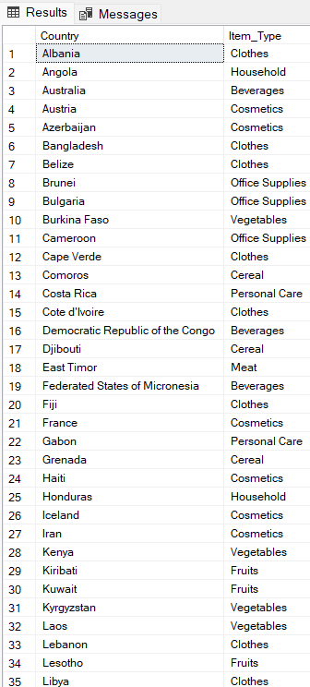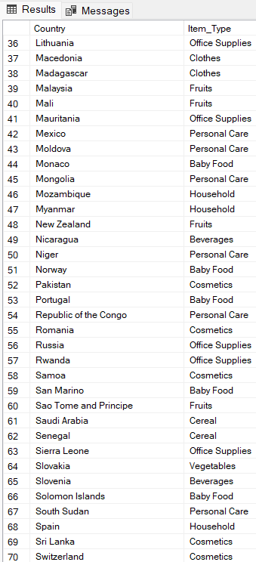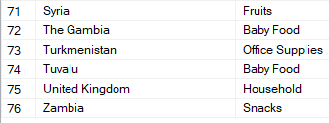

**(Least Sold Item by Each Country)**

**22. Most sold item by each country?**

WITH cte

AS (SELECT Country,

Item_Type,

Sum(Units_Sold) AS Total_Sold,

Dense_rank()

OVER(

partition BY Country

ORDER BY Sum(Units_Sold) ASC) Ranking

FROM [dbo].[amazon sales data]

GROUP BY Country,

Item_Type)

SELECT Country,

Item_Type

FROM cte

WHERE Ranking = 1

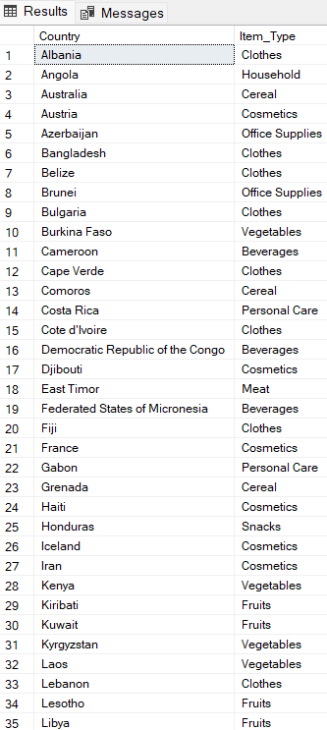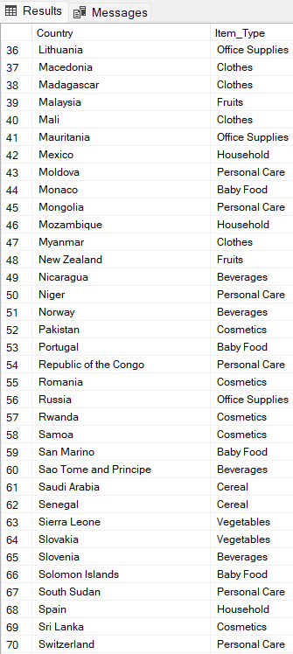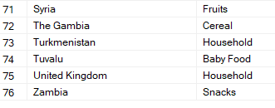

**(Total Sold Items by Region)**

**23.Highest to lowest total sold items by region?**

SELECT Region,

SUM(Units_Sold) AS Total_Sold_Items

FROM [dbo].[Amazon Sales data]

GROUP BY Region

ORDER BY Total_Sold_Items DESC

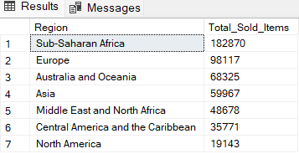

**(Most Sold Item by Region)**

**24. Find the most sold item by each region?**

WITH cte

AS (SELECT Region,

Item_Type,

SUM(Units_Sold) AS Unit_Sold,

DENSE_rank()

OVER(partition BY Region

ORDER BY SUM(Units_Sold) DESC) Ranking

FROM [dbo].[Amazon Sales data]

GROUP BY Region, Item_Type)

SELECT Region,

Item_Type,

Unit_Sold

FROM cte

WHERE Ranking=1

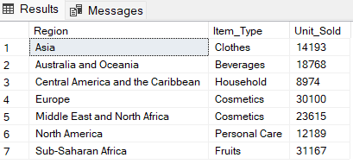

**(Least Sold Item by Region)**

**25. Find the least sold item by each region?**

WITH cte

AS (SELECT Region,

Item_Type,

SUM(Units_Sold) AS Unit_Sold,

DENSE_rank()

OVER(partition BY Region

ORDER BY SUM(Units_Sold) ASC) Ranking

FROM [dbo].[Amazon Sales data]

GROUP BY Region, Item_Type)

SELECT Region,

Item_Type,

Units_Sold

FROM cte WHERE Ranking=1

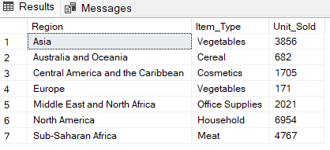

**(Total Revenue generated by Region)**

**26. Highest to lowest revenue generated region?**

WITH cte

AS (SELECT Region,

Item_Type,

SUM(Total_Revenue) AS total_revenue,

DENSE_rank()

OVER(partition BY Region

ORDER BY SUM(Total_Revenue) DESC) Ranking

FROM [dbo].[Amazon Sales data]

GROUP BY Region, Item_Type)

SELECT Region,

total_revenue

FROM cte

WHERE Ranking=1

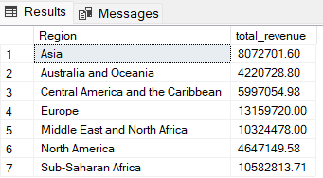

**(Total Profit by Region)**

**27. Highest to lowest profit region?**

WITH cte

AS (SELECT Region,

Item_Type,

SUM(Total_Profit) AS total_profit,

DENSE_rank()

OVER(partition BY Region

ORDER BY SUM(Total_Profit) DESC) Ranking

FROM [dbo].[Amazon Sales data]

GROUP BY Region, Item_Type)

SELECT Region,

total_profit

FROM cte

WHERE Ranking=1

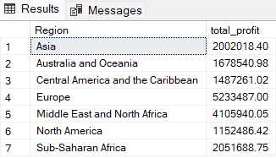

**(Types of Order Priority)**

**28. List of distinct Order Priorities?**

SELECT DISTINCT(Order_Priority) FROM [dbo].[Amazon Sales data]

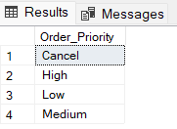

**(Highest Sold Item for High Priority)**

**29. Most highest priority item of all time in the online and offline market?**

WITH cte

AS (SELECT Item_Type

FROM [dbo].[Amazon Sales data]

WHERE Order_Priority = 'High')

SELECT TOP(1) Item_Type

FROM cte

GROUP BY Item_Type

ORDER BY COUNT(*) DESC

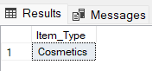

**(Highest Sold Item for Cancel Priority)**

**30. Most Cancel priority item of all time in online and offline market?**

WITH cte

AS (SELECT Item_Type

FROM [dbo].[Amazon Sales data]

WHERE Order_Priority = 'Cancel')

SELECT TOP(1) Item_Type

FROM cte

GROUP BY Item_Type

ORDER BY COUNT(*) DESC

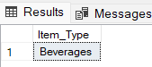

**(High Priority)**

**31. Highest to lowest sold items for Higher Priority?**

WITH cte

AS (SELECT * FROM [dbo].[Amazon Sales data] WHERE Order_Priority = 'High')

SELECT Item_Type,

SUM(Units_Sold) AS Unit_Sold

FROM cte

GROUP BY Item_Type

ORDER BY Unit_Sold DESC

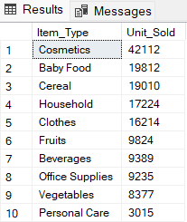

**(Cancel Priority)**

**32. Highest to lowest sold items for Cancel Priority?**

WITH cte

AS (SELECT * FROM [dbo].[Amazon Sales data] WHERE Order_Priority = 'Cancel')

SELECT Item_Type,

SUM(Units_Sold) AS Unit_Sold

FROM cte

GROUP BY Item_Type

ORDER BY Unit_Sold DESC

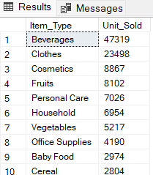

**(Total Profit)**

**33. Sum of the total profit generated from sales?**

SELECT SUM(Total_Profit) AS Total_Profit FROM [dbo].[Amazon Sales data]

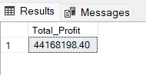

**(Top 5 Countries with Highest Profit)**

**34. List of top 5 countries with the highest profit?**

WITH cte

AS(SELECT Country,

SUM(Total_Profit) AS Total_Profit,

Rank()

OVER(Order BY SUM(Total_Profit) DESC) AS Ranking

FROM [dbo].[Amazon Sales data]

GROUP BY Country)

SELECT Country,

Total_Profit

FROM cte

WHERE Ranking IN (1,2,3,4,5)

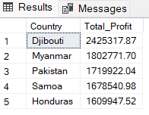

**(Top 5 Countries with Highest Revenue)**

**35. List of top 5 countries with the highest Revenue?**

WITH cte

AS(SELECT Country,

SUM(Total_Revenue) AS Total_Revenue,

Rank()

OVER(Order BY SUM(Total_Revenue) DESC) AS Ranking

FROM [dbo].[Amazon Sales data]

GROUP BY Country)

SELECT Country,

Total_Revenue

FROM cte

WHERE Ranking IN (1,2,3,4,5)

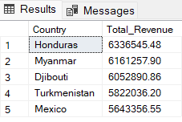

**(Top 5 Countries with Lowest Profit)**

**36. List of top 5 countries with the lowest profit?**

WITH cte

AS(SELECT Country,

SUM(Total_Profit) AS Total_Profit,

Rank()

OVER(Order BY SUM(Total_Profit) ASC) AS Ranking

FROM [dbo].[Amazon Sales data]

GROUP BY Country)

SELECT Country,

Total_Profit

FROM cte

WHERE Ranking IN (1,2,3,4,5)

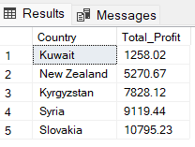

**(Top 5 Countries with Lowest Revenue)**

**37. List of top 5 countries with the lowest Revenue?**

WITH cte

AS(SELECT Country,

SUM(Total_Revenue) AS Total_Revenue,

Rank()

OVER(Order BY SUM(Total_Revenue) ASC) AS Ranking

FROM [dbo].[Amazon Sales data]

GROUP BY Country)

SELECT Country,

Total_Revenue

FROM cte

WHERE Ranking IN (1,2,3,4,5)

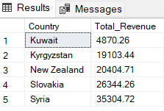

**(Profit by Sales Mode)**

**38. Total profit generated by different sales modes?**

SELECT Sales_Channel,

SUM(Total_Profit) AS Total_Profit

FROM [dbo].[Amazon Sales data]

GROUP BY Sales_Channel

ORDER BY SUM(Total_Profit) DESC

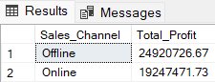

**(Most Profitable Item by Sales Mode)**

**39. The most profitable item in each sales mode?**

WITH cte

AS (SELECT Sales_Channel,

Item_Type,

Sum(Total_Profit) AS Total_Profit,

Rank()

OVER(

partition BY Sales_Channel

ORDER BY Sum(Total_Profit) DESC) Ranking

FROM [dbo].[amazon sales data]

GROUP BY Sales_Channel,

Item_Type)

SELECT Sales_Channel,

Item_Type,

Total_Profit

FROM cte

WHERE ranking = 1

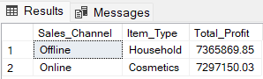

**(Least Profitable Item by Sales Mode)**

**40. The least profitable item in each sales mode?**

WITH cte

AS (SELECT Sales_Channel,

Item_Type,

Sum(Total_Profit) AS Total_Profit,

Rank()

OVER(

partition BY Sales_Channel

ORDER BY Sum(Total_Profit) ASC) Ranking

FROM [dbo].[amazon sales data]

GROUP BY Sales_Channel,

Item_Type)

SELECT Sales_Channel,

Item_Type,

Total_Profit

FROM cte

WHERE ranking = 1

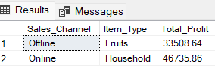

**-----------------------------------YEARLY ANALYSIS----------------------------------**

**(Yearly Total Profit)**

**41. Total profit for each year?**

SELECT Order_Year, SUM(Total_Profit) AS total_profit FROM [dbo].[Amazon Sales data]

GROUP BY Order_Year

Order BY total_profit DESC

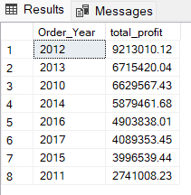

**(Yearly Revenue)**

**42. Total revenue generated for each year?**

SELECT Order_Year AS Year,

SUM(Total_Revenue) AS Revenue

FROM [dbo].[Amazon Sales data]

GROUP BY Order_Year

ORDER BY Revenue DESC

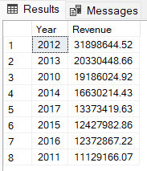

**(Highest Number of Orders)**

**43. Highest to lowest number of orders for each year?**

SELECT Order_Year,

SUM(Units_Sold) AS No_of_order

FROM [dbo].[Amazon Sales data]

GROUP BY Order_Year

ORDER BY No_of_order DESC

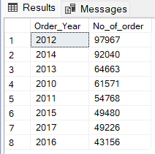

**(Most Sold Item Each Year)**

**44. The most sold item in each individual year?**

WITH cte

AS(SELECT Order_Year,

Item_Type,

Sum(Units_Sold) AS Unit_Sold,

Rank()

OVER(

partition BY Order_Year

ORDER BY Sum(Units_Sold) DESC) AS Ranking

FROM [dbo].[amazon sales data]

GROUP BY Order_Year,

Item_Type)

SELECT Order_Year AS Year, Item_Type

FROM cte

WHERE ranking = 1

ORDER BY order_year DESC

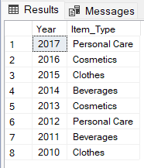

**(Least Sold Item Each Year)**

**45. The least sold item in each individual year?**

WITH cte

AS(SELECT Order_Year,

Item_Type,

Sum(Units_Sold) AS Unit_Sold,

Rank()

OVER(

partition BY Order_Year

ORDER BY Sum(Units_Sold) ASC) AS Ranking

FROM [dbo].[amazon sales data]

GROUP BY Order_Year,

Item_Type)

SELECT Order_Year AS Year, Item_Type

FROM cte

WHERE ranking = 1

ORDER BY order_year DESC

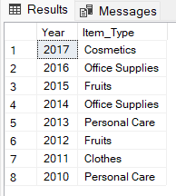

**----------------------------------MONTHLY ANALYSIS--------------------------------**

**(Yearly-Monthly Total Products Sold)**

**46. Total products sold for each year-month combination?**

SELECT Order_Year AS Year,

Order_Month_Name AS Month,

SUM(Units_Sold) AS Total_Order

FROM [dbo].[Amazon Sales data]

GROUP BY Order_Year,

Order_Month_Number,

Order_Month_Name

ORDER BY Order_Year,

Order_Month_Number ASC

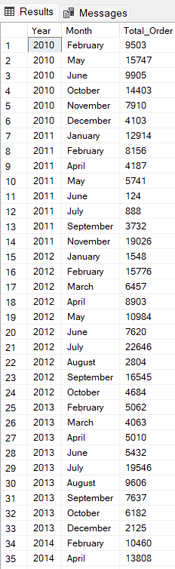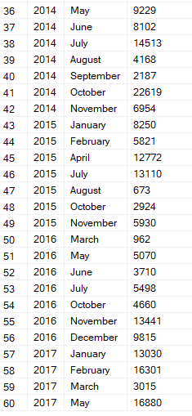

**(Most Sold Item Each Year-Month)**

**47. The most sold item in each year-month?**

WITH cte

AS (SELECT Ship_Year,

Order_Month_Number,

Order_Month_Name,

Item_Type,

Sum(Units_Sold) AS Total_Sold,

Dense_rank()

OVER (

partition BY Ship_Year, Order_Month_Number, Order_Month_Name

ORDER BY Sum(Units_Sold) DESC) AS Ranking

FROM [dbo].[amazon sales data]

GROUP BY Ship_Year,

Order_Month_Number,

Order_Month_Name,

Item_Type)

SELECT Ship_Year AS Year,

Order_Month_Name AS Month,

Item_Type,

Total_Sold

FROM cte

WHERE ranking = 1

ORDER BY Ship_Year DESC,

Total_Sold DESC;

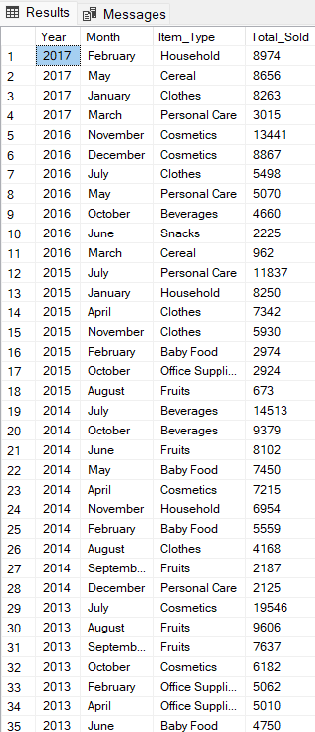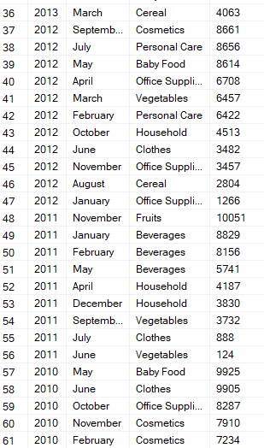

**(Least Sold Item Each Year-Month)**

**48. The least sold item in each year-month?**

WITH cte

AS (SELECT Ship_Year,

Order_Month_Number,

Order_Month_Name,

Item_Type,

Sum(Units_Sold) AS Total_Sold,

Dense_rank()

OVER (

partition BY Ship_Year, Order_Month_Number, Order_Month_Name

ORDER BY Sum(Units_Sold) ASC) AS Ranking

FROM [dbo].[amazon sales data]

GROUP BY Ship_Year,

Order_Month_Number,

Order_Month_Name,

Item_Type)

SELECT Ship_Year AS Year,

Order_Month_Name AS Month,

Item_Type,

Total_Sold

FROM cte

WHERE ranking = 1

ORDER BY Ship_Year DESC,

Total_Sold ASC;

